Table of Contents

People and Projects 4

Address Book 5

Income Distribution 7

Income Distribution 7

Voucher Distribution 12

Expense Distribution 22

Vehicle Logs 22

Create Statement 28

Statement of Account 31

Other Expenses 35

Configuration 39

Vehicles 39

Phone Lines 43

Phone Pins 47

Telecommunications Companies 51

Bank and Cash 56

Bank Accounts 57

Bank Reconciliation 57

Check Clearing 57

Fund Transfer Clearing 57

Petty Cash 57

Monitoring 57

Bills Exchange 57

Replenishment 57

Transfers 57

Daily Transactions 57

Fund Transfer 57

Internal Bank Transfers 57

Internal Account Transfers 57

Bank Transfers 57

Checks 57

Check Payments 57

Check Monitoring 57

Exchanges 57

Configuration 57

Currencies 57

Denominations 57

Banks 58

Accounting 59

Journal Entries 60

Journal Vouchers 60

Journal Entries 60

Journal Items 60

Analytic Journal Items 60

Charts 60

Chart of Accounts 60

Chart of Analytic Accounts 60

Periodical Processing 60

*Draft Entries 60

*Reconciliation 60

Opening Balance 60

*Statements 60

*Recurring Entries 60

End of Period 60

Fund Allocation 60

Revaluations 60

Reporting 60

Statement of Accounts 60

Regional Reports 61

Configuration 61

Financial Accounting 61

Analytic Accounting 61

ACCPAC Extension Tools 61

Miscellaneous 61

Administration 61

# People and Projects

## Address Book

1. Purpose

The address book serves as the table of the contact details of missionaries and project accounts. It is being referred on by the analytic accounts and the SOA sending functionality for email references.

1. Views
   1. **List View**

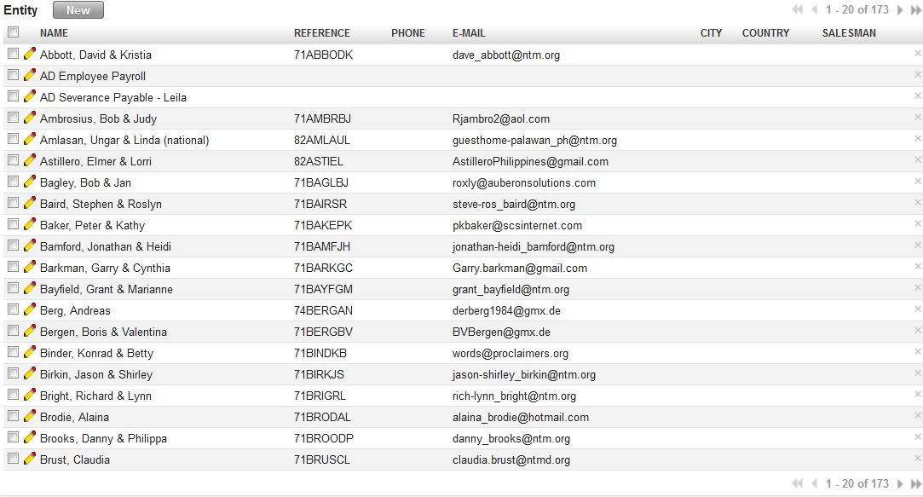

Figure 1 - List View of Address Book (All Menus under Address Book)

* 1. **Form View**

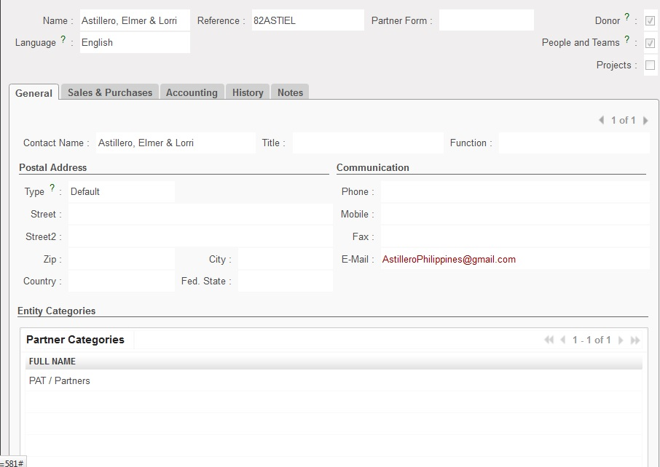

Figure 2 - Form View of Address Book (All Menus under Address Book)

1. Menu and Access Right
   1. Menu – People and Projects > Address Book > [People and Teams Information, Projects Information]
   2. Access Rights
2. Required Fields
3. Workflow
4. User Action
5. Field Visibility
6. Reports and Prints Outs
7. Errors

## Income Distribution

### Income Distribution

1. Purpose

All income that needs to be distributed shall be processed using income distribution. Income Distribution will automatically create the journal entries upon completion of the process.

1. Views
   1. **List View**

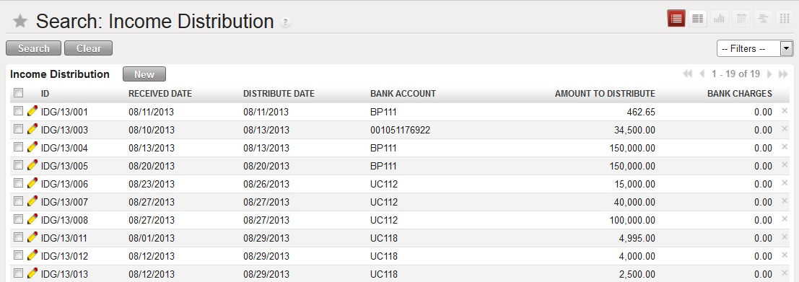

Figure 3 - List View of Income Distribution

* 1. **Form View**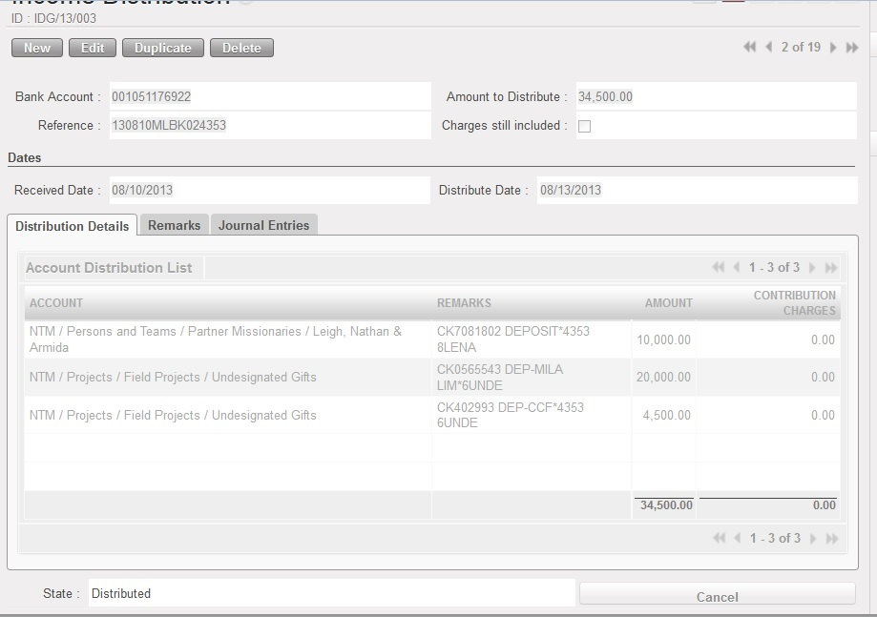

Figure 4 - Form View of Income Distribution (Distribution Details Tab)

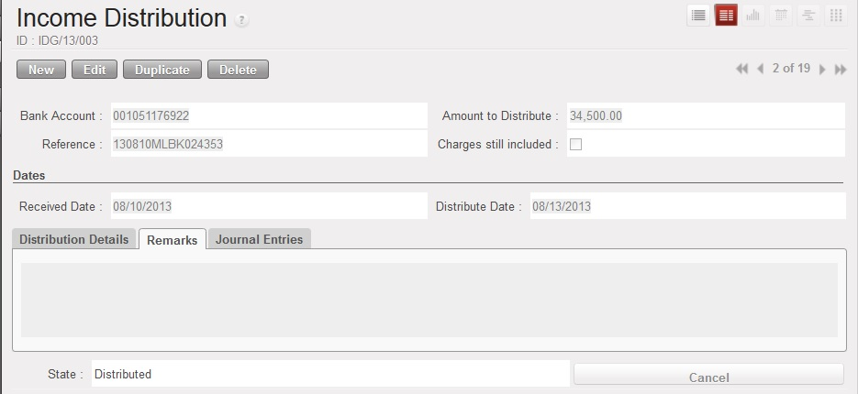

Figure 5 - Form View of Income DIstribution (Remarks Tab)

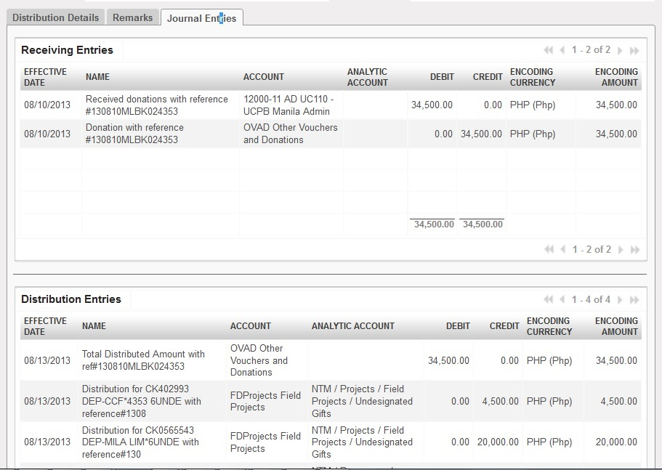

Figure 6 - Form View of Income DIstribution (Journal Entries Tab)

1. Menu and Access Right
   1. Menu – People and Projects > *Income Distribution*> *Income Distribution*
   2. Access Rights

|  |  |  |  |  |
| --- | --- | --- | --- | --- |
| **Role** | **Read** | **Write** | **Create** | **Delete** |
| **Income Distribution Manager** | Yes | Yes | Yes | No |

1. Required Fields (required by State)

|  |  |
| --- | --- |
| **Field Name** | **Required in** |
| **Bank Account** | Draft |
| **Amount to Distribute** | Draft |
| **Reference** | Draft |
| **Received Date** | Draft |
| **Bank Charges** | Draft (Charges still included = True ) |
| **Distribute Date** | Money Received |

1. Workflow



Figure 7 Workflow of Income Distribution Process

|  |  |  |
| --- | --- | --- |
| **State** | **Description** | **Visible Buttons** |
| **Draft** | Initial state of the record. User will encode the details of the received money. | **Receive Money** |
| **Money Received** | Money has been received to the bank.  This will also be the state clicking the ‘**Cancel Distribution Transaction**’ button during the ‘**Received Money Distributed**’ | **Cancel Receiving Transaction**  **Distribute Donation** |
| **Received Money Distributed** | Record has been reviewed by the Branch manager | **Cancel Distribution Transaction**  **Cancel Transaction** |
| **Transaction Cancelled** | The record will be in ‘**Cancelled**’ state when:   1. The ‘**Cancel Receiving Transaction**’ button is clicked. 2. The ‘**Cancel Transaction**’ button is clicked. |  |

1. User Action

|  |  |  |
| --- | --- | --- |
| **Button** | **Action** | **Triggred By** |
| **Receive Money** | Creates journal entries for the receiving part of the transaction. | **Income Distribution Manager** |
| **Cancel Receiving Transaction** | Removes the created JEs for the received money.  Set the state to ‘**Transaction Cancelled**’. | **Income Distribution Manager** |
| **Distribute Donation** | Creates JEs for the distribution part of the transaction. | **Income Distribution Manager** |
| **Cancel Distribution Transaction** | Removes the created JEs for the distribution transaction.  Set the state to ‘**Money Received**’. | **Income Distribution Manager** |
| **Cancel Transaction** | Removes the created JEs for the distribution and receiving transaction.  Set the state to ‘**Transaction Cancelled**’ | **Income Distribution Manager** |

1. Field Visibility

All fields are available for the Income Distribution Manager.

1. Reports and Prints Outs

No Available Reports/Print Outs

1. Errors

|  |  |  |
| --- | --- | --- |
| **ERROR CODE** | **MESSAGE** | **SOLUTION** |
| ERR-001 | *If Charges are still included, bank charges must be greater than 0.00!* | Bank Charges must always be greater than equal to ZERO before clicking the ‘Receive Money’ button when the ‘Charges still included’ checkbox is True. |
| ERR-002 | *You must have a distribution list before distribution!* | Add accounts to where the received money will be distributed. |
| ERR-003 | *Total received amount is not equal to the total amount to be distributed!* | Check the distribution list if the total amount is equal to the amount to be distributed |

### Voucher Distribution

1. Purpose

All vouchers that came to NTM Philippines in DBF format and use the NTMA Accounting Software will be processed using the voucher distribution.

1. Views
   1. **List View**

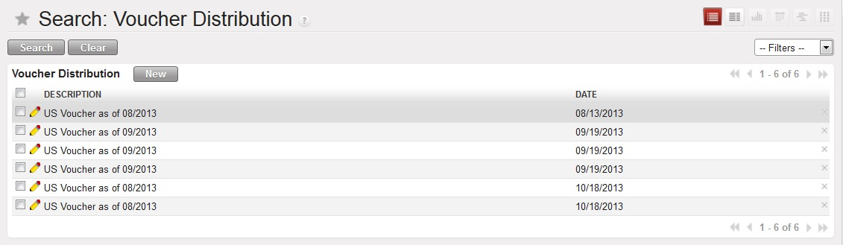

Figure 8 - List View of the Voucher Distribution

* 1. **Form View**

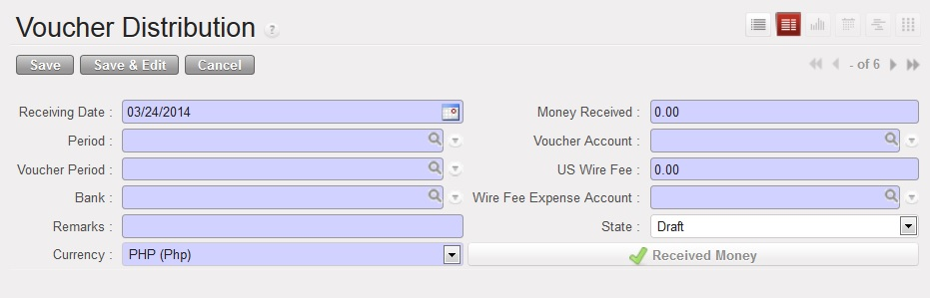

Figure 9 - Initial Form (Receiving Money Transaction)

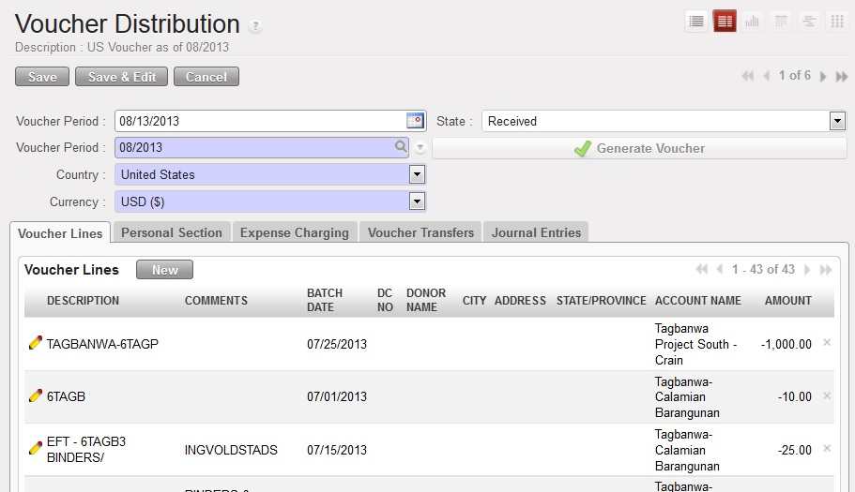

Figure 10 - Voucher Generation

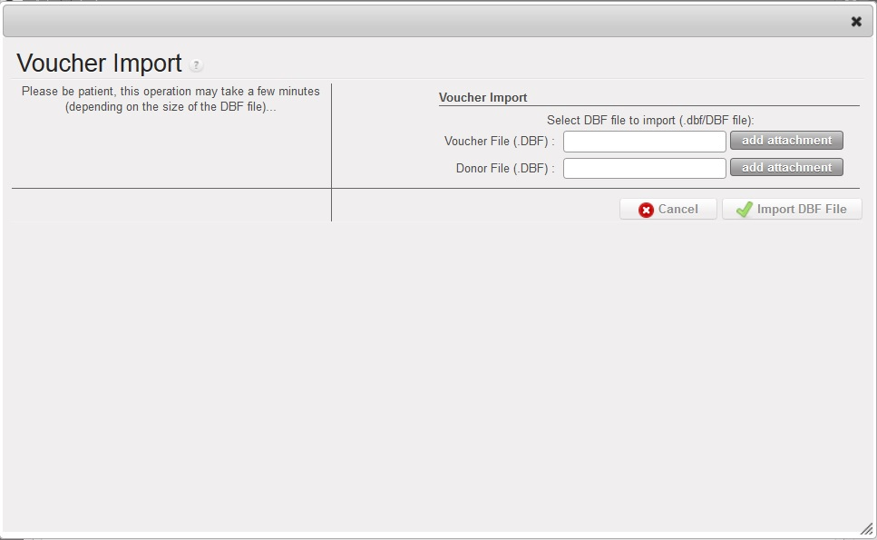

Figure 11 - Voucher and Donor File Upload

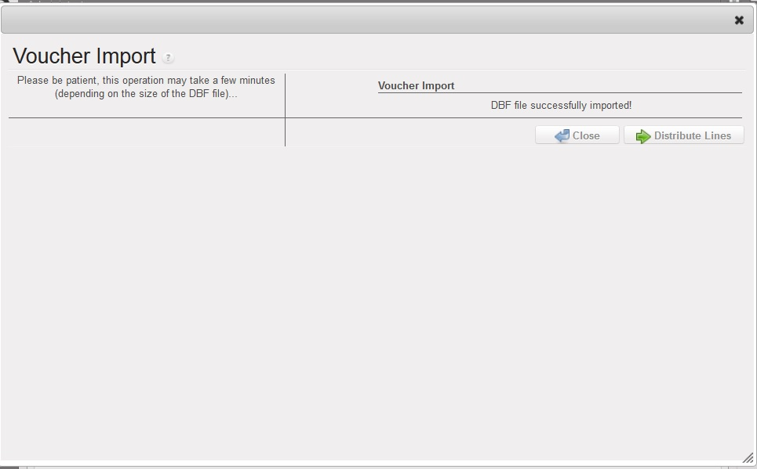

Figure 12 - Distribution of Lines

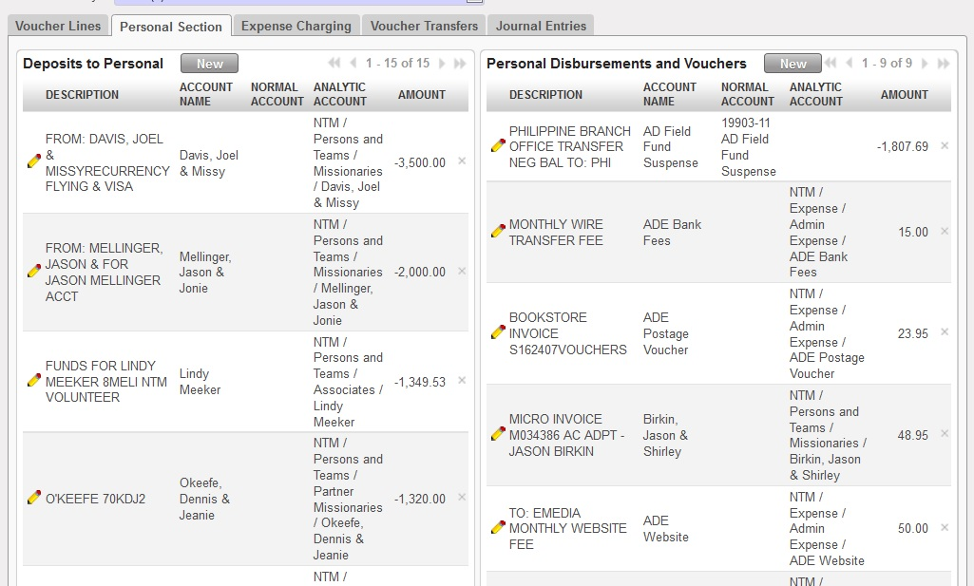

Figure 13 - Personal Section Tab

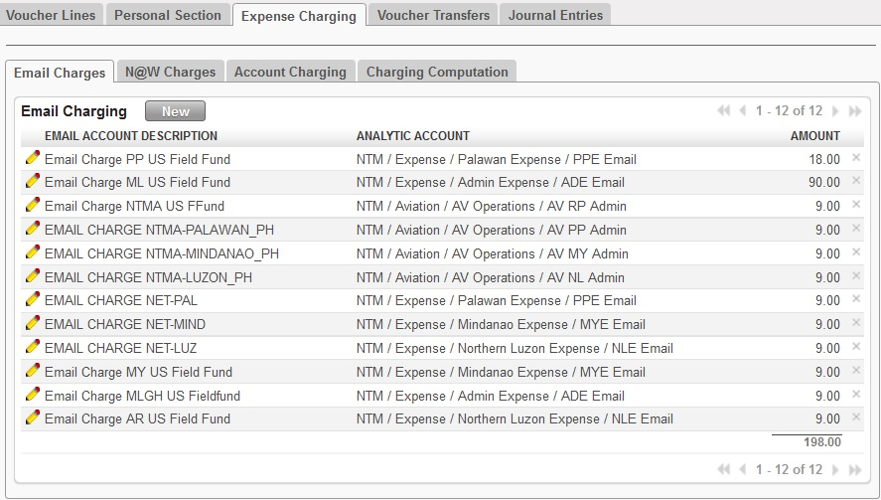

Figure 14 - Expense Charging (Email Charges)

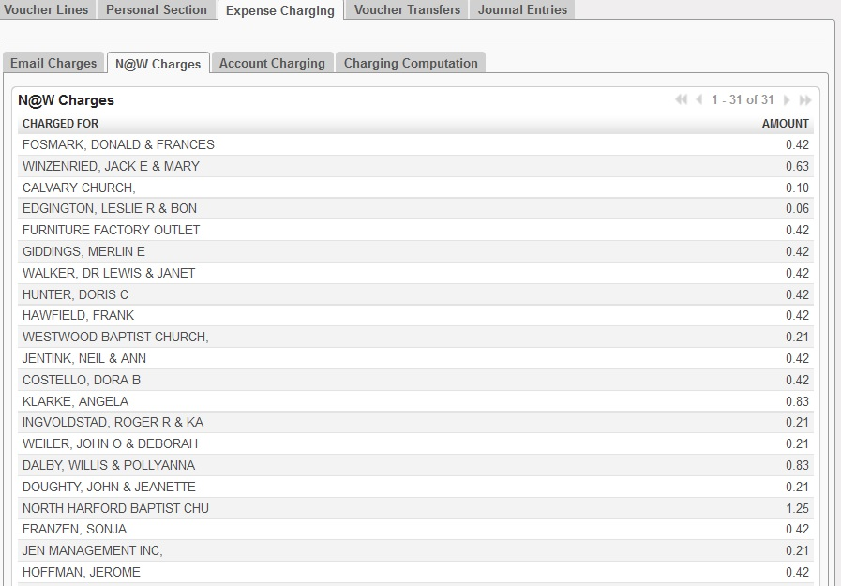

Figure 15 - Expense Charging (N@W Charges)

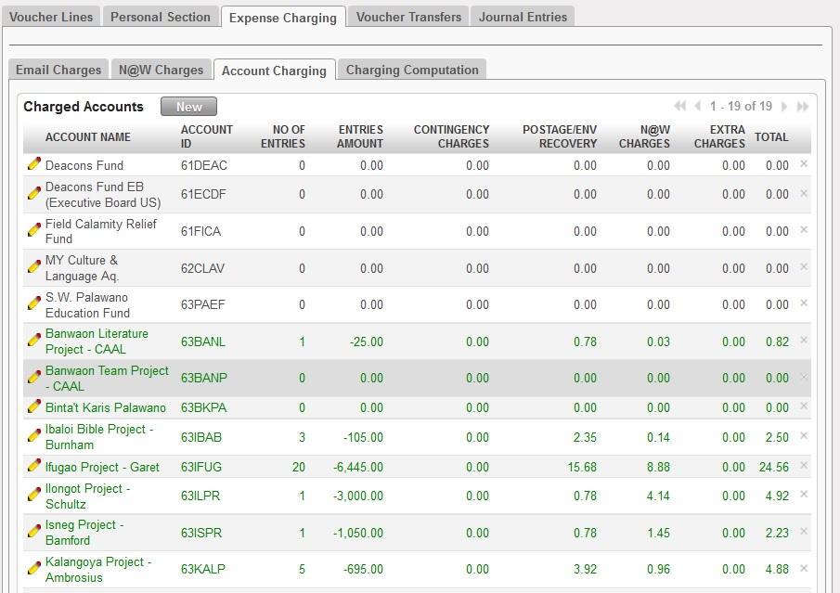

Figure 16 - Expense Charging (Account Charging)

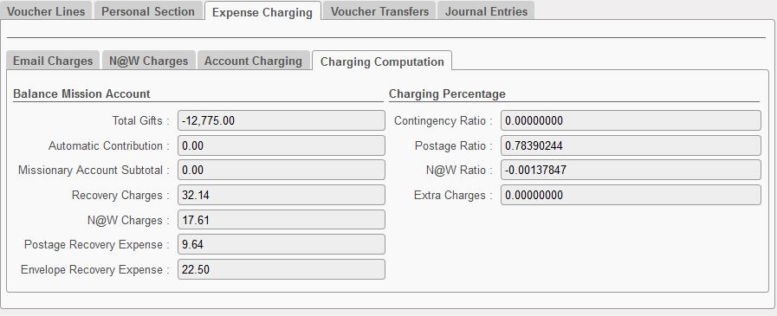

Figure 17 - Expense Charging (Charging Computation)

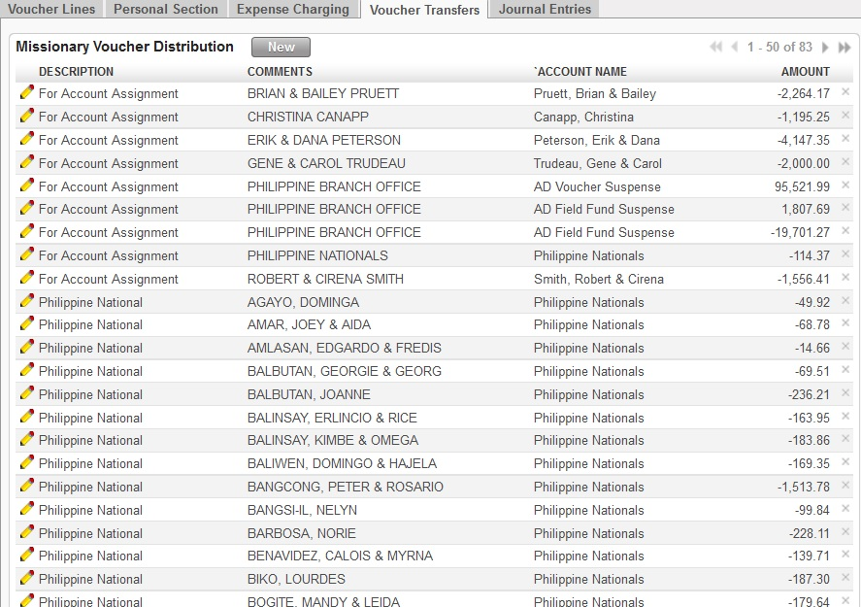

Figure 18 - Voucher Transfers

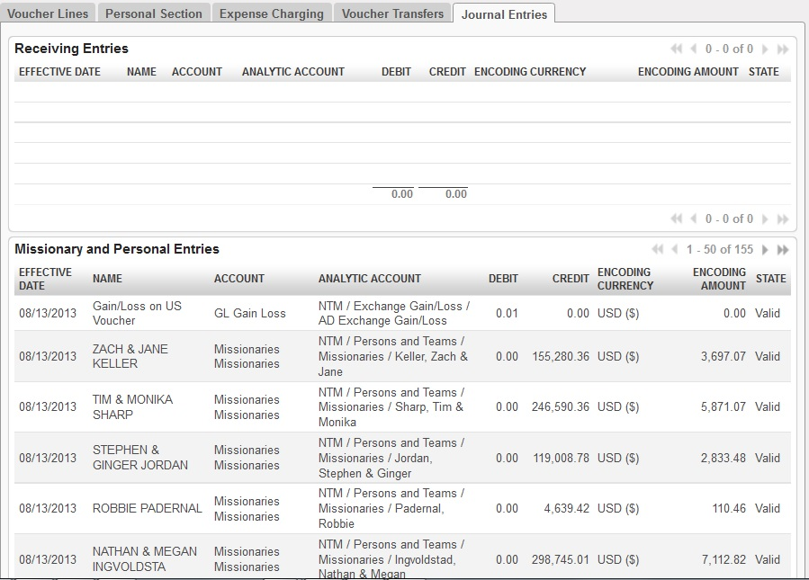

Figure 19 - Journal Entries

1. Menu and Access Right
   1. Menu – People and Projects > *Income Distribution*> *Voucher Distribution*
   2. Access Rights

|  |  |  |  |  |
| --- | --- | --- | --- | --- |
| **Role** | **Read** | **Write** | **Create** | **Delete** |
| **Voucher Distribution Manager** | Yes | Yes | Yes | No |

1. Required Fields (required by State)

|  |  |
| --- | --- |
| **Field Name** | **Required in** |
| **Receiving Date** | Draft |
| **Period** | Draft |
| **Voucher Period** | Draft |
| **Bank** | Draft |
| **Remarks** | Draft |
| **Currency** | Draft |
| **Money Received** | Draft |
| **Voucher Account** | Draft |
| **Wire Fee** | Draft |
| **Wire Fee Expense Account** | Draft |
|  |  |

1. Workflow



Figure 20 Workflow of Income Distribution Process

|  |  |  |
| --- | --- | --- |
| **State** | **Description** | **Visible Buttons** |
| **Draft** | Initial state of the record. User will encode the details of the received money. | **Receive Money** |
| **Money Received** | Money has been received to the bank.  This will also be the state clicking the ‘**Cancel Distribution Transaction**’ button during the ‘**Received Money Distributed**’ | **Cancel Receiving Transaction**  **Distribute Donation** |
| **Received Money Distributed** | Record has been reviewed by the Branch manager | **Cancel Distribution Transaction**  **Cancel Transaction** |
| **Transaction Cancelled** | The record will be in ‘**Cancelled**’ state when:   1. The ‘**Cancel Receiving Transaction**’ button is clicked. 2. The ‘**Cancel Transaction**’ button is clicked. |  |

1. User Action

|  |  |  |
| --- | --- | --- |
| **Button** | **Action** | **Triggred By** |
| **Receive Money** | Creates journal entries for the receiving part of the transaction. | **Income Distribution Manager** |
| **Cancel Receiving Transaction** | Removes the created JEs for the received money.  Set the state to ‘**Transaction Cancelled**’. | **Income Distribution Manager** |
| **Distribute Donation** | Creates JEs for the distribution part of the transaction. | **Income Distribution Manager** |
| **Cancel Distribution Transaction** | Removes the created JEs for the distribution transaction.  Set the state to ‘**Money Received**’. | **Income Distribution Manager** |
| **Cancel Transaction** | Removes the created JEs for the distribution and receiving transaction.  Set the state to ‘**Transaction Cancelled**’ | **Income Distribution Manager** |

1. Field Visibility

All fields are available for the Income Distribution Manager.

1. Reports and Prints Outs

No Available Reports/Print Outs

1. Errors

|  |  |  |
| --- | --- | --- |
| **ERROR CODE** | **MESSAGE** | **SOLUTION** |
| IDG-001 | *If Charges are still included, bank charges must be greater than 0.00!* | Bank Charges must always be greater than equal to ZERO before clicking the ‘Receive Money’ button when the ‘Charges still included’ checkbox is True. |
| IDG-002 | *You must have a distribution list before distribution!* | Add accounts to where the received money will be distributed. |
| IDG-003 | *Total received amount is not equal to the total amount to be distributed!* | Check the distribution list if the total amount is equal to the amount to be distributed |

## Expense Distribution

### Vehicle Logs

1. Purpose

This records all the trips that a certain vehicle made. This also creates the expenses of the missionaries.

1. Views
   1. **List View**

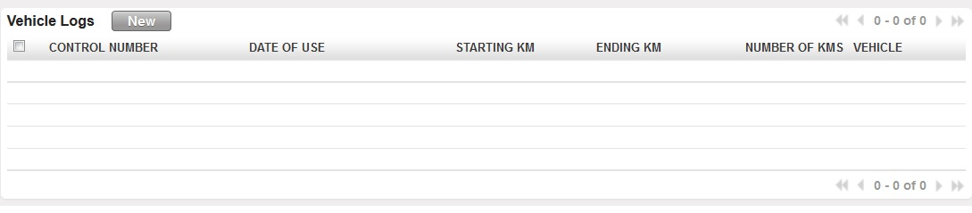

Figure 21 - Vehicle Logs List View

* 1. **Form View**

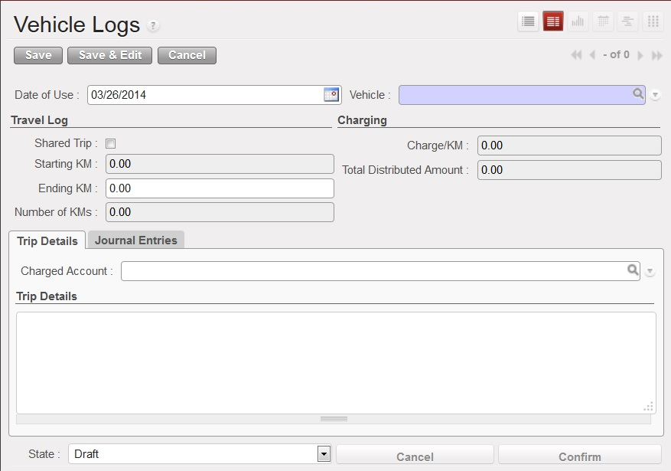

Figure 22 - Form View when shared trip is FALSE

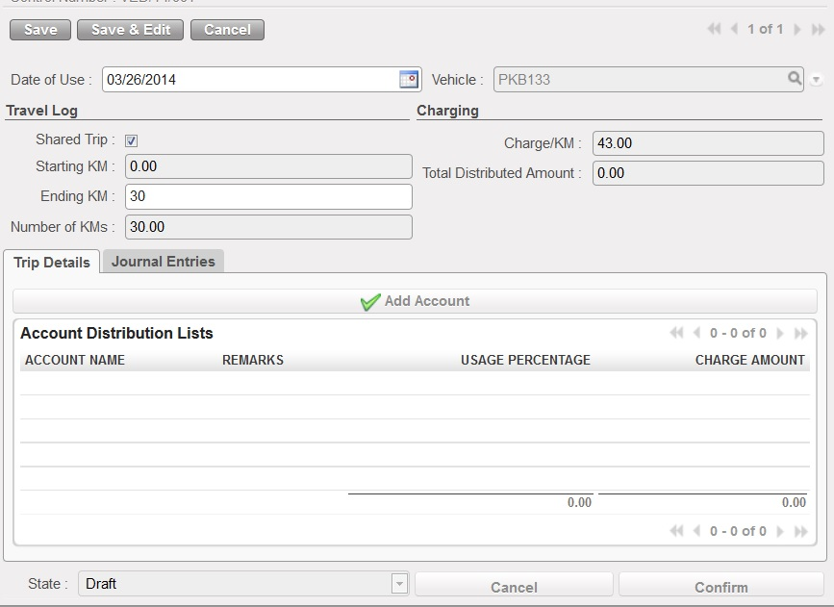

Figure 23 - Form View when shared trip is true

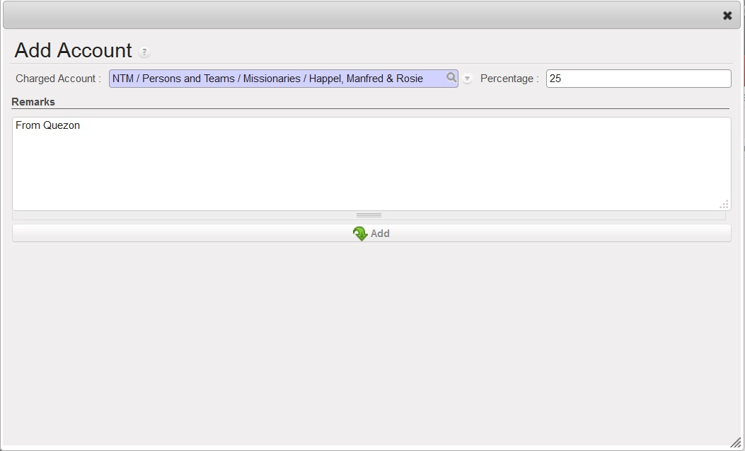

Figure 24 - Add Account Form

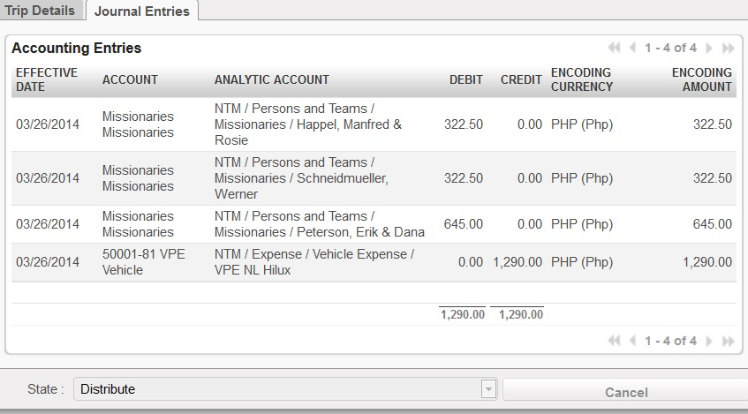

Figure 25 - Journal Entries Tab

1. Menu and Access Right
   1. Menu – People and Projects > *Expense Distribution*> *Vehicle Logs*
   2. Access Rights

|  |  |  |  |  |
| --- | --- | --- | --- | --- |
| **Role** | **Read** | **Write** | **Create** | **Delete** |
| **Vehicle Logger** | Yes | Yes | Yes | No |
| **Vehicle Manager** | Yes | Yes | Yes | Yes |

1. Required Fields (required by State)

|  |  |
| --- | --- |
| **Field Name** | **Required in** |
| **Vehicle ID** | Draft |
| **Charged Account** | Draft |

1. Workflow



Figure 26 - Workflow of Vehicle Logs Procedure

|  |  |  |
| --- | --- | --- |
| **State** | **Description** | **Visible Buttons** |
| **Draft** | Initial state of the record. User will encode the details of the distribution. | **Confirm** |
| **Confirmed** | Changes to the details will be disabled. | **Cancel**  **Distribute** |
| **Distributed** | Journal entries created. | **Cancel** |
| **Cancelled** | On ‘**Cancelled**’ state, all the fields will not be enabled for edit. |  |

1. User Action

|  |  |  |
| --- | --- | --- |
| **Button** | **Action** | **Triggered By** |
| **Confirm** | Disables all fields for editing. | **Vehicle Logger** |
| **Distribute** | Creates the necessary journal entries. | **Vehicle Logger/Vehicle Manager** |
| **Cancel** | Cancel the transaction and removes the created journal entry when state is ‘Distributed’. | **Vehicle Manager** |

1. Field Visibility

All fields are available for the Vehicle Logger/Vehicle Manager.

1. Reports and Prints Outs

No Available Reports/Print Outs

1. Errors

|  |  |  |
| --- | --- | --- |
| **ERROR CODE** | **MESSAGE** | **SOLUTION** |
| ERR-004 | *Negative ending KM is not allowed.* | Ending KM must be greater than the starting KM. |
| ERR-005 | *Percentage of the shared trips is already 100%!* | Adjust percentages to be able to add accounts. |
| ERR-006 | *Shared trip percentage is over by (total_percent - 100)! Adjust your percentage!* | Adjust the percentage of the distribution. |

### Create Statement

1. Purpose

This wizard is used to import the CALLS.DBF file from the phone manager to OpenERP. This would also create the record based on specified user inputs.

1. Views
   1. **Form View**

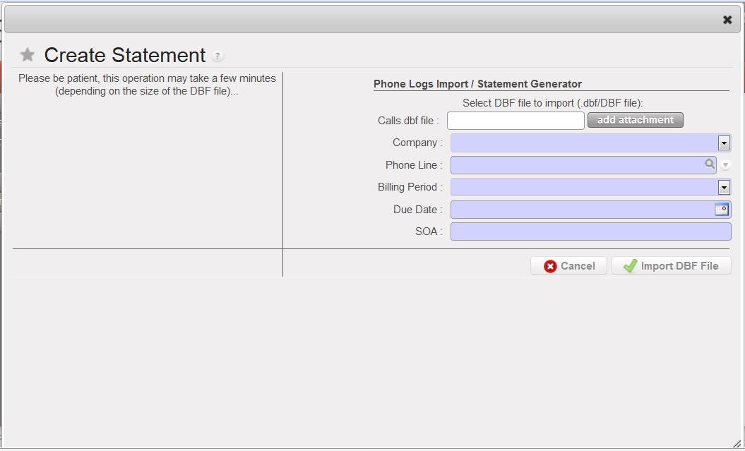

Figure 27 - Import File Form View

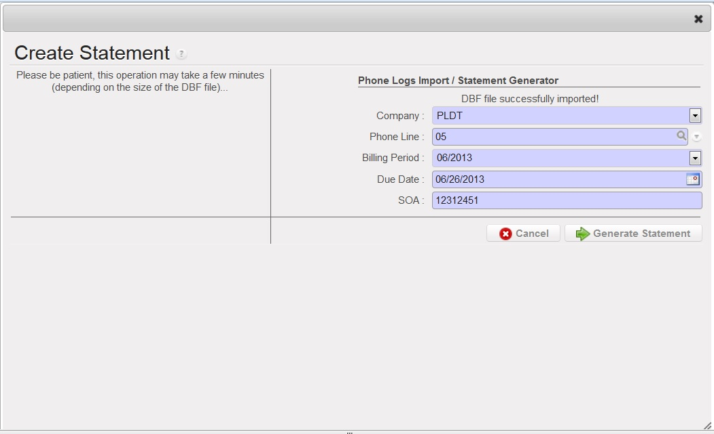

Figure 28 - Generate Statement Form View

1. Menu and Access Right
   1. Menu – People and Projects > *Expense Distribution*> *Create Statement*
   2. Access Rights

|  |  |  |  |  |
| --- | --- | --- | --- | --- |
| **Role** | **Read** | **Write** | **Create** | **Delete** |
| **Phone Log Updater** | Yes | Yes | Yes | No |
| **Phone Manager** | Yes | Yes | Yes | Yes |

1. Required Fields (required by State)

|  |  |
| --- | --- |
| **Field Name** | **Required in** |
| **Vehicle ID** | Draft |
| **Charged Account** | Draft |

|  |  |
| --- | --- |
| **Field Name** | **Required in** |
| **Company** | Draft, Imported |
| **Phone Line** | Draft, Imported |
| **Billing Period** | Draft, Imported |
| **Due Date** | Draft, Imported |
| **SOA** | Draft, Imported |
| **Calls.dbf File** | Draft |

1. Workflow



Figure 29 - Workflow of Create Statement

|  |  |  |
| --- | --- | --- |
| **State** | **Description** | **Visible Buttons** |
| **Import File** | This is the state where the user imports the dbf file. | **Import DBF File, Cancel** |
| **Generate Statement** | This will generate the | **Generate Statement, Cancel** |

1. User Action

|  |  |  |
| --- | --- | --- |
| **Button** | **Action** | **Triggered By** |
| **Import DBF File** | Creates a copy of the imported DBF File. | **Phone Manager** |
| **Generate Statement** | Creates statement of account with data from CALLS.DBF File | **Phone Manager** |
| **Cancel** | Closes the current create statement form. | **Phone Manager** |

1. Field Visibility

All fields are available for the Phone Log Update/Phone Manager

1. Reports and Prints Outs

No Available Reports/Print Outs

1. Errors

|  |  |  |
| --- | --- | --- |
| **ERROR CODE** | **MESSAGE** | **SOLUTION** |
| ERR-007 | *Statement for SOA (SOA_NO) has already been created* | SOA number is unique between statements. |

### Statement of Account

1. Purpose

Statement of Account manages all the created statement of accounts from an imported DBF file. It creates the distribution to accounts and charging entries.

1. Views
   1. **List View**

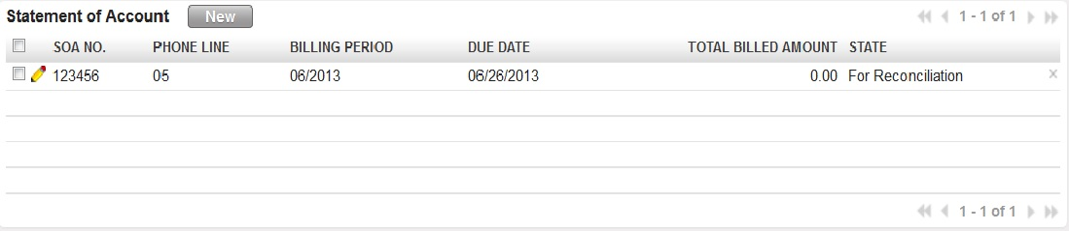

Figure 30 - Statement of Account List

* 1. **Form View**

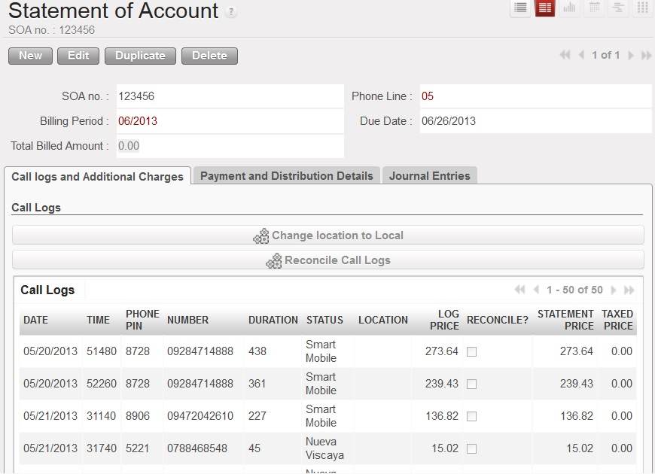

Figure 31 - Main Form

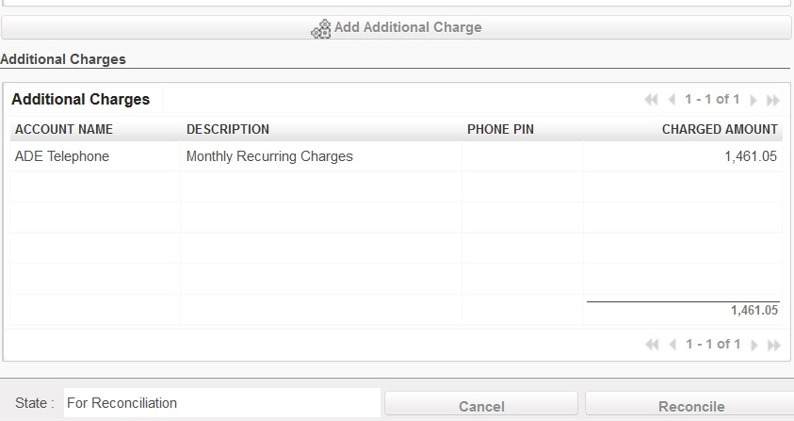

Figure 32 - Additional Charges Lists

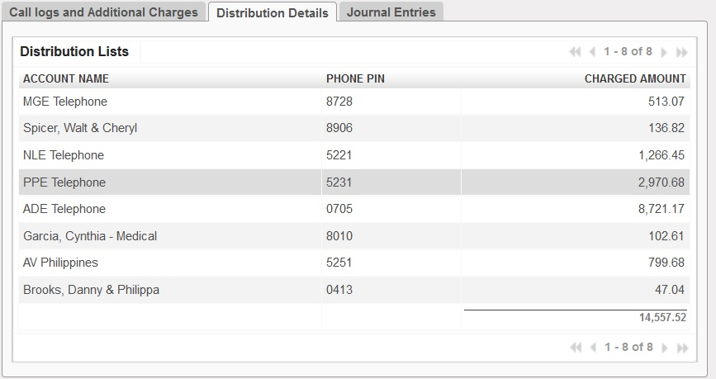

Figure 33 - Distribution Details Tab

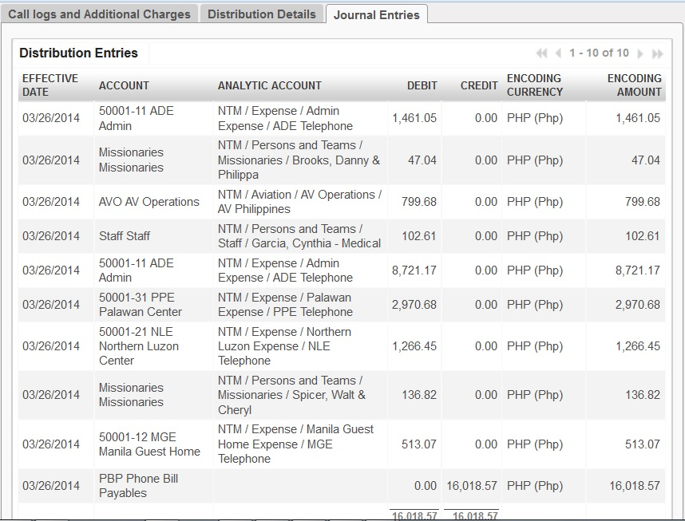

Figure 34 - Journal Entries Tab

1. Menu and Access Right
   1. Menu – People and Projects > *Expense Distribution*> *Statement of Accounts*
   2. Access Rights

|  |  |  |  |  |
| --- | --- | --- | --- | --- |
| **Role** | **Read** | **Write** | **Create** | **Delete** |
| **Phone Log Updater** | Yes | Yes | Yes | No |
| **Phone Manager** | Yes | Yes | Yes | Yes |

1. Required Fields (required by State)

No fields are required since the details came from the Create Statement Procedure.

1. Workflow



Figure 35 - Workflow of Create Statement

|  |  |  |
| --- | --- | --- |
| **State** | **Description** | **Visible Buttons** |
| **Draft** | Initial State. | **Reconcile, Cancel** |
| **Reconciled** | In this state, the call logs have been distributed to specific accounts. | **Distribute, Cancel** |
| **Distributed** | In this state, the journal entries had been created. | **Cancel** |
| **Cancelled** | In this state, the created journal entries are deleted. |  |

1. User Action

|  |  |  |
| --- | --- | --- |
| **Button** | **Action** | **Triggered By** |
| **Change Location to Local** | Change the location field of all logs to ‘**Local**’ | **Phone Manager** |
| **Reconcile Call Logs** | Creates statement of account with data from CALLS.DBF File | **Phone Manager** |
| **Add Additional Account** | Closes the current create statement form. | **Phone Manager** |
| **Reconcile** | Sets the state to ‘**Reconciled**’. | **Phone Manager** |
| **Distribute** | Sets the state to ‘**Distributed**’.  Distributes the call logs to specific phone pins/account ready for charging. **Phone Manager** | **Phone Manager** |
| **Charge Phone Expenses** | Sets the state to ‘**Charged**’.  Creates the journal entries for the charged accounts. | **Phone Manager** |

1. Field Visibility

All fields are available for the Phone Manager.

1. Reports and Prints Outs

No Available Reports/Print Outs

1. Errors

|  |  |  |
| --- | --- | --- |
| **ERROR CODE** | **MESSAGE** | **SOLUTION** |
| ERR-008 | *Please change the location!* | Change the location of all the international calls. For local calls, click the change location to local button |
| ERR-009 | *All call logs must be reconciled first before reconciling the statement!* | Click the Reconcile Call Logs button to compute for the taxed price per call log. |
| ERR-010 | *Please check the reconciliation! Total amount of call logs and additional charges is not equal to billed amount.* | Change the value of the Total Billed Amount field to the sum of call logs taxed price and the additional charges. |
| ERR-011 | *Pin # is not yet configured. Please create this phone pin on the Phone Pin Configuration.* | Create the Phone Pin to the list of phone pines. |
| ERR-012 | *No account connected to the phone pin.* | Check the configuration of the phone pin. |

### Other Expenses

1. Purpose

This procedure records all the other expenses that is being paid using checks.

1. Views
   1. **List View**

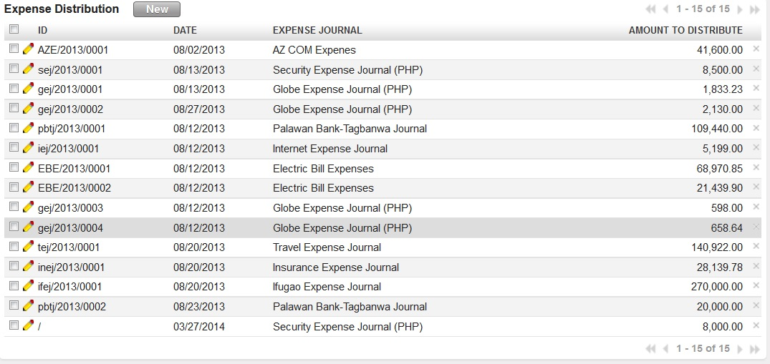

Figure 36 - Other Expenses List

* 1. **Form View**

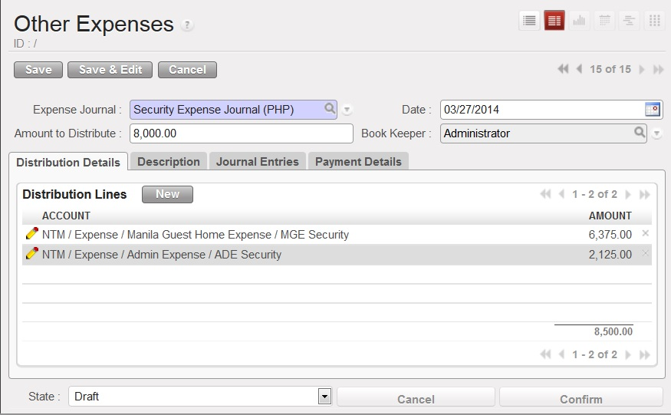

Figure 37 – Other Expenses (Distribution Details/Initial Form)

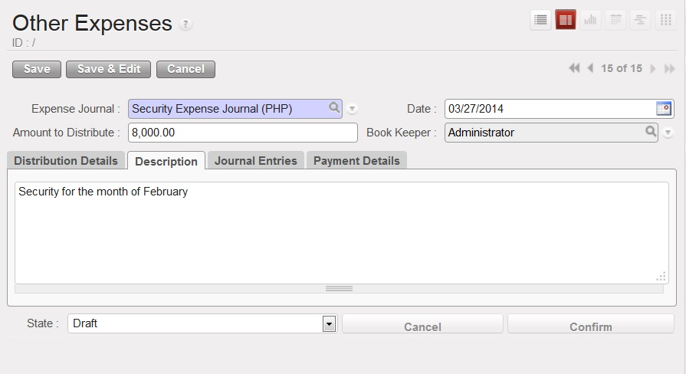

Figure 38 - Expense Description Tab

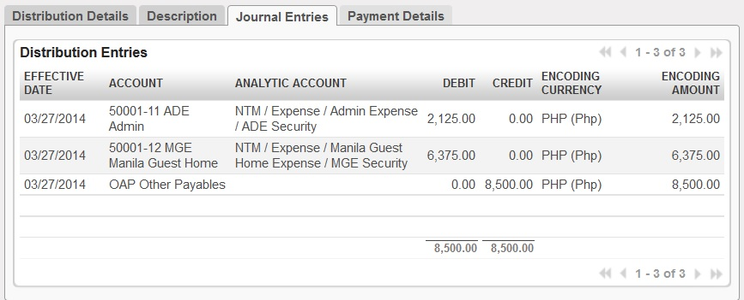

Figure 39 - Journal Entries Tab

1. Menu and Access Right
   1. Menu – People and Projects > *Expense Distribution*> *Other Expenses*
   2. Access Rights

|  |  |  |  |  |
| --- | --- | --- | --- | --- |
| **Role** | **Read** | **Write** | **Create** | **Delete** |
| **Expense Manager** | Yes | Yes | Yes | No |

1. Required Fields (required by State)

|  |  |
| --- | --- |
| **Field Name** | **Required in** |
| **Expense Journal** | Draft |

1. Workflow



Figure 40 - Workflow of Create Statement

|  |  |  |
| --- | --- | --- |
| **State** | **Description** | **Visible Buttons** |
| **Draft** |  |  |
| **Confirmed** |  |  |
| **Distributed** |  |  |
| **Cancelled** |  |  |

1. User Action

|  |  |  |
| --- | --- | --- |
| **Button** | **Action** | **Triggered By** |
| **Import DBF File** | Creates a copy of the imported DBF File. | **Phone Manager** |
| **Generate Statement** | Creates statement of account with data from CALLS.DBF File | **Phone Manager** |
| **Cancel** | Closes the current create statement form. | **Phone Manager** |

1. Field Visibility

All fields are available for the Vehicle Logger/Vehicle Manager.

1. Reports and Prints Outs

No Available Reports/Print Outs

1. Errors

|  |  |  |
| --- | --- | --- |
| **ERROR CODE** | **MESSAGE** | **SOLUTION** |
| ERR-013 | *Zero expense amounts are not allowed.* | Change the amount to distribute to the total amount of distribution lines. |
| ERR-014 | *Zero charged amount is not allowed.* | Change the amounts of the distribution line where the amount is ZERO. |
| ERR-015 | *Expense amount is not equal to distribution line amount total.* | Change the amount to distribute to the total amount of distribution lines. |

### Direct Bank Expenses

1. Purpose

This wizard is used to import the CALLS.DBF file from the phone manager to OpenERP. This would also create the record based on specified user inputs.

1. Views
   1. **Form View**



Figure 41 - Import File Form View



Figure 42 - Generate Statement Form View

1. Menu and Access Right
   1. Menu – People and Projects > *Expense Distribution*> *Create Statement*
   2. Access Rights

|  |  |  |  |  |
| --- | --- | --- | --- | --- |
| **Role** | **Read** | **Write** | **Create** | **Delete** |
| **Phone Log Updater** | Yes | Yes | Yes | No |
| **Phone Manager** | Yes | Yes | Yes | Yes |

1. Required Fields (required by State)

|  |  |
| --- | --- |
| **Field Name** | **Required in** |
| **Vehicle ID** | Draft |
| **Charged Account** | Draft |

|  |  |
| --- | --- |
| **Field Name** | **Required in** |
| **Company** | Draft, Imported |
| **Phone Line** | Draft, Imported |
| **Billing Period** | Draft, Imported |
| **Due Date** | Draft, Imported |
| **SOA** | Draft, Imported |
| **Calls.dbf File** | Draft |

1. Workflow



Figure 43 - Workflow of Create Statement

|  |  |  |
| --- | --- | --- |
| **State** | **Description** | **Visible Buttons** |
| **Import File** | This is the state where the user imports the dbf file. | **Import DBF File, Cancel** |
| **Generate Statement** | This will generate the | **Generate Statement, Cancel** |

1. User Action

|  |  |  |
| --- | --- | --- |
| **Button** | **Action** | **Triggered By** |
| **Import DBF File** | Creates a copy of the imported DBF File. | **Phone Manager** |
| **Generate Statement** | Creates statement of account with data from CALLS.DBF File | **Phone Manager** |
| **Cancel** | Closes the current create statement form. | **Phone Manager** |

1. Field Visibility

All fields are available for the Vehicle Logger/Vehicle Manager.

1. Reports and Prints Outs

No Available Reports/Print Outs

1. Errors

|  |  |  |
| --- | --- | --- |
| **ERROR CODE** | **MESSAGE** | **SOLUTION** |
| ERR-007 | *Statement for SOA (SOA_NO) has already been created* | SOA number is unique between statements. |

## Configuration

### Vehicles

1. Purpose

This wizard is used to import the CALLS.DBF file from the phone manager to OpenERP. This would also create the record based on specified user inputs.

1. Views
   1. **Form View**



Figure 44 - Import File Form View



Figure 45 - Generate Statement Form View

1. Menu and Access Right
   1. Menu – People and Projects > *Expense Distribution*> *Create Statement*
   2. Access Rights

|  |  |  |  |  |
| --- | --- | --- | --- | --- |
| **Role** | **Read** | **Write** | **Create** | **Delete** |
| **Phone Log Updater** | Yes | Yes | Yes | No |
| **Phone Manager** | Yes | Yes | Yes | Yes |

1. Required Fields (required by State)

|  |  |
| --- | --- |
| **Field Name** | **Required in** |
| **Vehicle ID** | Draft |
| **Charged Account** | Draft |

|  |  |
| --- | --- |
| **Field Name** | **Required in** |
| **Company** | Draft, Imported |
| **Phone Line** | Draft, Imported |
| **Billing Period** | Draft, Imported |
| **Due Date** | Draft, Imported |
| **SOA** | Draft, Imported |
| **Calls.dbf File** | Draft |

1. Workflow



Figure 46 - Workflow of Create Statement

|  |  |  |
| --- | --- | --- |
| **State** | **Description** | **Visible Buttons** |
| **Import File** | This is the state where the user imports the dbf file. | **Import DBF File, Cancel** |
| **Generate Statement** | This will generate the | **Generate Statement, Cancel** |

1. User Action

|  |  |  |
| --- | --- | --- |
| **Button** | **Action** | **Triggered By** |
| **Import DBF File** | Creates a copy of the imported DBF File. | **Phone Manager** |
| **Generate Statement** | Creates statement of account with data from CALLS.DBF File | **Phone Manager** |
| **Cancel** | Closes the current create statement form. | **Phone Manager** |

1. Field Visibility

All fields are available for the Vehicle Logger/Vehicle Manager.

1. Reports and Prints Outs

No Available Reports/Print Outs

1. Errors

|  |  |  |
| --- | --- | --- |
| **ERROR CODE** | **MESSAGE** | **SOLUTION** |
| ERR-007 | *Statement for SOA (SOA_NO) has already been created* | SOA number is unique between statements. |

### Phone Lines

1. Purpose

This wizard is used to import the CALLS.DBF file from the phone manager to OpenERP. This would also create the record based on specified user inputs.

1. Views
   1. **Form View**



Figure 47 - Import File Form View



Figure 48 - Generate Statement Form View

1. Menu and Access Right
   1. Menu – People and Projects > *Expense Distribution*> *Create Statement*
   2. Access Rights

|  |  |  |  |  |
| --- | --- | --- | --- | --- |
| **Role** | **Read** | **Write** | **Create** | **Delete** |
| **Phone Log Updater** | Yes | Yes | Yes | No |
| **Phone Manager** | Yes | Yes | Yes | Yes |

1. Required Fields (required by State)

|  |  |
| --- | --- |
| **Field Name** | **Required in** |
| **Vehicle ID** | Draft |
| **Charged Account** | Draft |

|  |  |
| --- | --- |
| **Field Name** | **Required in** |
| **Company** | Draft, Imported |
| **Phone Line** | Draft, Imported |
| **Billing Period** | Draft, Imported |
| **Due Date** | Draft, Imported |
| **SOA** | Draft, Imported |
| **Calls.dbf File** | Draft |

1. Workflow



Figure 49 - Workflow of Create Statement

|  |  |  |
| --- | --- | --- |
| **State** | **Description** | **Visible Buttons** |
| **Import File** | This is the state where the user imports the dbf file. | **Import DBF File, Cancel** |
| **Generate Statement** | This will generate the | **Generate Statement, Cancel** |

1. User Action

|  |  |  |
| --- | --- | --- |
| **Button** | **Action** | **Triggered By** |
| **Import DBF File** | Creates a copy of the imported DBF File. | **Phone Manager** |
| **Generate Statement** | Creates statement of account with data from CALLS.DBF File | **Phone Manager** |
| **Cancel** | Closes the current create statement form. | **Phone Manager** |

1. Field Visibility

All fields are available for the Vehicle Logger/Vehicle Manager.

1. Reports and Prints Outs

No Available Reports/Print Outs

1. Errors

|  |  |  |
| --- | --- | --- |
| **ERROR CODE** | **MESSAGE** | **SOLUTION** |
| ERR-007 | *Statement for SOA (SOA_NO) has already been created* | SOA number is unique between statements. |

### Phone Pins

1. Purpose

This wizard is used to import the CALLS.DBF file from the phone manager to OpenERP. This would also create the record based on specified user inputs.

1. Views
   1. **Form View**



Figure 50 - Import File Form View



Figure 51 - Generate Statement Form View

1. Menu and Access Right
   1. Menu – People and Projects > *Expense Distribution*> *Create Statement*
   2. Access Rights

|  |  |  |  |  |
| --- | --- | --- | --- | --- |
| **Role** | **Read** | **Write** | **Create** | **Delete** |
| **Phone Log Updater** | Yes | Yes | Yes | No |
| **Phone Manager** | Yes | Yes | Yes | Yes |

1. Required Fields (required by State)

|  |  |
| --- | --- |
| **Field Name** | **Required in** |
| **Vehicle ID** | Draft |
| **Charged Account** | Draft |

|  |  |
| --- | --- |
| **Field Name** | **Required in** |
| **Company** | Draft, Imported |
| **Phone Line** | Draft, Imported |
| **Billing Period** | Draft, Imported |
| **Due Date** | Draft, Imported |
| **SOA** | Draft, Imported |
| **Calls.dbf File** | Draft |

1. Workflow



Figure 52 - Workflow of Create Statement

|  |  |  |
| --- | --- | --- |
| **State** | **Description** | **Visible Buttons** |
| **Import File** | This is the state where the user imports the dbf file. | **Import DBF File, Cancel** |
| **Generate Statement** | This will generate the | **Generate Statement, Cancel** |

1. User Action

|  |  |  |
| --- | --- | --- |
| **Button** | **Action** | **Triggered By** |
| **Import DBF File** | Creates a copy of the imported DBF File. | **Phone Manager** |
| **Generate Statement** | Creates statement of account with data from CALLS.DBF File | **Phone Manager** |
| **Cancel** | Closes the current create statement form. | **Phone Manager** |

1. Field Visibility

All fields are available for the Vehicle Logger/Vehicle Manager.

1. Reports and Prints Outs

No Available Reports/Print Outs

1. Errors

|  |  |  |
| --- | --- | --- |
| **ERROR CODE** | **MESSAGE** | **SOLUTION** |
| ERR-007 | *Statement for SOA (SOA_NO) has already been created* | SOA number is unique between statements. |

### Telecommunications Companies

1. Purpose

This wizard is used to import the CALLS.DBF file from the phone manager to OpenERP. This would also create the record based on specified user inputs.

1. Views
   1. **Form View**



Figure 53 - Import File Form View



Figure 54 - Generate Statement Form View

1. Menu and Access Right
   1. Menu – People and Projects > *Expense Distribution*> *Create Statement*
   2. Access Rights

|  |  |  |  |  |
| --- | --- | --- | --- | --- |
| **Role** | **Read** | **Write** | **Create** | **Delete** |
| **Phone Log Updater** | Yes | Yes | Yes | No |
| **Phone Manager** | Yes | Yes | Yes | Yes |

1. Required Fields (required by State)

|  |  |
| --- | --- |
| **Field Name** | **Required in** |
| **Vehicle ID** | Draft |
| **Charged Account** | Draft |

|  |  |
| --- | --- |
| **Field Name** | **Required in** |
| **Company** | Draft, Imported |
| **Phone Line** | Draft, Imported |
| **Billing Period** | Draft, Imported |
| **Due Date** | Draft, Imported |
| **SOA** | Draft, Imported |
| **Calls.dbf File** | Draft |

1. Workflow



Figure 55 - Workflow of Create Statement

|  |  |  |
| --- | --- | --- |
| **State** | **Description** | **Visible Buttons** |
| **Import File** | This is the state where the user imports the dbf file. | **Import DBF File, Cancel** |
| **Generate Statement** | This will generate the | **Generate Statement, Cancel** |

1. User Action

|  |  |  |
| --- | --- | --- |
| **Button** | **Action** | **Triggered By** |
| **Import DBF File** | Creates a copy of the imported DBF File. | **Phone Manager** |
| **Generate Statement** | Creates statement of account with data from CALLS.DBF File | **Phone Manager** |
| **Cancel** | Closes the current create statement form. | **Phone Manager** |

1. Field Visibility

All fields are available for the Vehicle Logger/Vehicle Manager.

1. Reports and Prints Outs

No Available Reports/Print Outs

1. Errors

|  |  |  |
| --- | --- | --- |
| **ERROR CODE** | **MESSAGE** | **SOLUTION** |
| ERR-007 | *Statement for SOA (SOA_NO) has already been created* | SOA number is unique between statements. |

# Bank and Cash

## Bank Accounts

## Bank Reconciliation

### Check Clearing

### Fund Transfer Clearing

## Petty Cash

### Monitoring

### Bills Exchange

### Replenishment

### **Transfers**

#### P/C to P/C Transfer

#### Petty Cash to Bank Transfer

### Daily Transactions

### **Fund** **Transfer**

### Internal Bank Transfers

### Internal Account Transfers

### Bank Transfers

#### Unscheduled

#### Scheduled

#### All Requests

#### Generate Transfer Requests

## Checks

### Check Payments

### Check Monitoring

## Exchanges

## Configuration

### Currencies

### Denominations

### Banks

# Accounting

## Journal Entries

### Journal Vouchers

### Journal Entries

### Journal Items

### Analytic Journal Items

## Charts

### Chart of Accounts

### Chart of Analytic Accounts

## Periodical Processing

### *Draft Entries

### *Reconciliation

### Opening Balance

### *Statements

### *Recurring Entries

### End of Period

#### Close a Period

#### Close a Fiscal Year

### Fund Allocation

### Revaluations

#### Monthly Revaluations

#### Revised Revaluation

## Reporting

### Statement of Accounts

#### Statements

#### Statement Requests

### Regional Reports

#### Generate Regional Report

#### Regional Profit and Loss

#### Regional Entries

#### Regional Uploader

## Configuration

### Financial Accounting

#### Periods

#### Journals

#### Accounts

### Analytic Accounting

#### Analytic Journals

#### Analytic Accounts

### ACCPAC Extension Tools

### Miscellaneous

# Administration